# CD LAB 5

NAME: Janvii RV

SRN: PES2UG22CS232

DATE: 20/03/2025

Code:

lexer.l :

%{

#define YYSTYPE char*

#include <unistd.h>

#include "parser.tab.h"

#include <stdio.h>

extern void yyerror(const char *); // declare the error handling function

%}

/* Regular definitions */

digit [0-9]

letter [a-zA-Z]

id {letter}({letter}|{digit})*

digits {digit}+

opFraction (\.{digits})?

opExponent ([Ee][+-]?{digits})?

number {digits}{opFraction}{opExponent}

%option yylineno

%%

\/\/(.*) ; // ignore comments

[\t\n] ; // ignore whitespaces

"(" {return *yytext;}

")" {return *yytext;}

"." {return *yytext;}

"," {return *yytext;}

"*" {return *yytext;}

"+" {return *yytext;}

";" {return *yytext;}

"-" {return *yytext;}

"/" {return *yytext;}

"=" {return *yytext;}

">" {return *yytext;}

"<" {return *yytext;}

{number} {

yylval = strdup(yytext); //stores the value of the number to be used later for symbol table insertion

return T_NUM;

}

{id} {

yylval = strdup(yytext); //stores the identifier to be used later for symbol table insertion

return T_ID;

}

. {} // anything else => ignore

%%

parser.y

%{

#include "quad_generation.c"

#include <stdio.h>

#include <stdlib.h>

#include <string.h>

#define YYSTYPE char*

void yyerror(char* s); // error handling function

int yylex(); // declare the function performing lexical analysis

extern int yylineno; // track the line number

int yywrap() {

return 1; // Signals end of input

}

FILE* icg_quad_file;

int temp_no = 1;

%}

%token T_ID T_NUM

/* specify start symbol */

%start START

%%

START : ASSGN {

printf("Valid syntax\n");

YYACCEPT; // If program fits the grammar, syntax is valid

}

/* Grammar for assignment */

ASSGN : T_ID '=' E { //call quad_code_gen with appropriate parameters

quad_code_gen($1, $3, "=", "");

}

;

/* Expression Grammar */

E : E '+' T { //create a new temporary and call quad_code_gen with appropriate parameters

$$= new_temp();

char* op =strdup("+");

quad_code_gen($$,$1,op,$3);

}

| E '-' T { //create a new temporary and call quad_code_gen with appropriate parameters

$$= new_temp();

char* op =strdup("-");

quad_code_gen($$,$1,op,$3);

}

| T

;

T : T '*' F { //create a new temporary and call quad_code_gen with appropriate parameters

$$= new_temp();

char* op =strdup("*");

quad_code_gen($$,$1,op,$3);

}

| T '/' F { //create a new temporary and call quad_code_gen with appropriate parameters

$$= new_temp();

char* op =strdup("/");

quad_code_gen($$,$1,op,$3);

}

| F

;

F : '(' E ')' { $$= strdup($2); }

| T_ID { $$= strdup($1); }

| T_NUM { $$= strdup($1); }

;

%%

/* error handling function */

void yyerror(char* s)

{

printf("Error :%s at %d \n",s,yylineno);

}

/* main function - calls the yyparse() function which will in turn drive yylex() as well */

int main(int argc, char* argv[])

{

icg_quad_file = fopen("icg_quad.txt","w");

yyparse();

fclose(icg_quad_file);

return 0;

}

quad_generation.c

#include <stdio.h>

#include <stdlib.h>

#include <string.h>

#include "quad_generation.h"

void quad_code_gen(char* a, char* b, char* op, char* c)

{

    //use fprintf to output the quadruple code to icg_quad_file

    printf("%s, %s, %s, %s\n", op, b, c, a);

    fprintf(icg_quad_file, "%s %s %s %s\n", op, b, c, a);

}

char* new_temp()    //returns a pointer to a new temporary

{

    char* temp = (char*)malloc(sizeof(char)*4);

    sprintf(temp, "t%d", temp_no);

    ++temp_no;

    return temp;

}

quad_generation.h

extern FILE* icg_quad_file;     //pointer to the output file

extern int temp_no;             //variable to keep track of current temporary count

void quad_code_gen(char* a, char* b, char* op, char* c);

char* new_temp();

Input:

1:

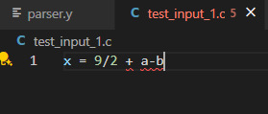

2:

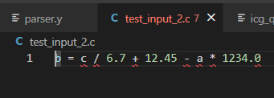

Output Screenshot:

1:

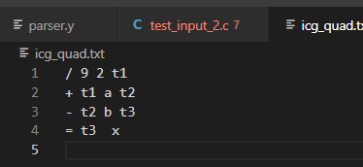

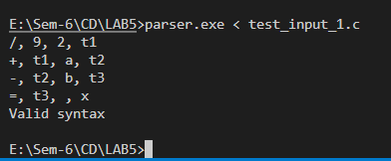

2:

